

Water Quality C*

Score:___/[Total] Rank:__________

Introduction and Instructions
Hello Science Olympiad competitors, be sure to note the following while taking the test.

- Please provide the necessary information requested on the previous page! It will make everything go a lot more smoothly.
- Please show your work and write your answers on the provided answer sheet! I will not be grading the test document. Make sure to box your answers on the answer sheet so I know what to look for.
- I will be manually grading each free-response, so make sure you carefully show each step so that if you make a mistake, I can still give points for work. Make it clear which problem you are working on at any point. For example, if you are working on problem 2.c., please write down 2.c. at the start of the problem.
- There is a periodic table on the following page. Constants, values, etc. will be provided in/before the question if necessary.
- If you believe there is a mistake in the exam, please ask right away so I can clarify for you and the rest of the test-takers as soon as possible.
- Good luck and have fun!

If you have any questions about the exam after it has concluded whether you are a Yosemite SO competitor or just taking the tests for practice, or if you are reviewing the solutions and notice a mistake, or have any water quality-related questions to this exam, please email me at mayurchhitu@gmail.com .

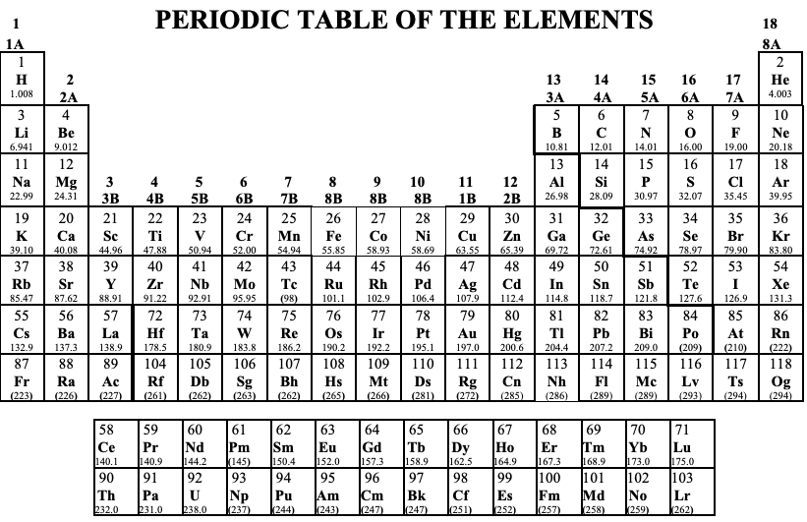
Multiple Choice/ True-False/ Short Answers
(2 points each*, 50 questions)
*Question 27 is worth 6 points in total and split in three parts.
*Question 34 is worth 4 points in total and split into two parts.

Part I: Marine & Estuary Ecology
- Based on the following image, the large fish is a:

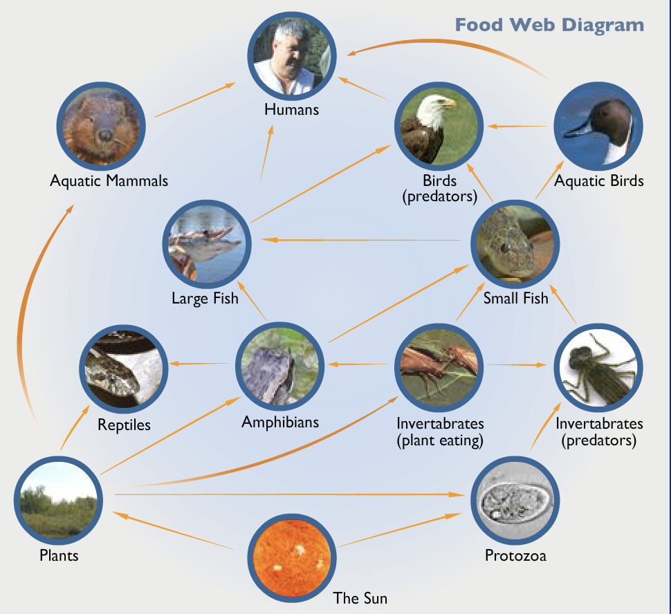

  - Tertiary consumer
  - Secondary consumer
  - Primary consumer
  - Producer
- Which of the following describes water’s special properties?
  - Water is a universal solvent.
  - Water has a low heat of vaporization.
  - Water has unusual changes in state.
  - Water molecules form hydrogen bonds with each other.
  - Liquid water has a low viscosity.
- Which of the following is not a valid reason or an example that calls for enforcing top-down controls in marine water columns:
  - Commercial fishing can remove a considerable proportion of the stock of a particular fish species, leading to depletions.
  - Biomanipulation of coastal phytoplankton growth to increase nutrient supply.
  - Trophic cascading.
  - Marine fish habitats not bounded by land often drift into areas inappropriate for their survival.
- Complete the following equation by correctly numbering each product (labeled as A, B, C, and D:
  - 106 CH₂O + 16 NH₃ + 1 H₃PO₄ + 1 O₂ » A CO₂ + B NH₃ + C H₃PO₄ + D H₂O
- The ratio of carbon, nitrogen, and phosphorous in the preceding equation (Question 4) is known as:
- The reaction, N₂ + 3H₂ » 2NH₃ » organic N, refers to which nitrogenous phase:
  - Ammonification
  - Nitrification
  - Denitrification
  - Fixation
- Identify a major issue with nitrogen enrichment in a body of water inhabited by plants and animals.
- (Tie-breaker 1) Compound(s) that do not serve to maintain osmotic balance in coastal environments:
  - Betaines
  - Prolines
  - Dimethylsulphoniopropionate (DMSP)
  - Dimethyl sulfoxide (DMSO)
- Which of the following type of wetland identifies this bog:
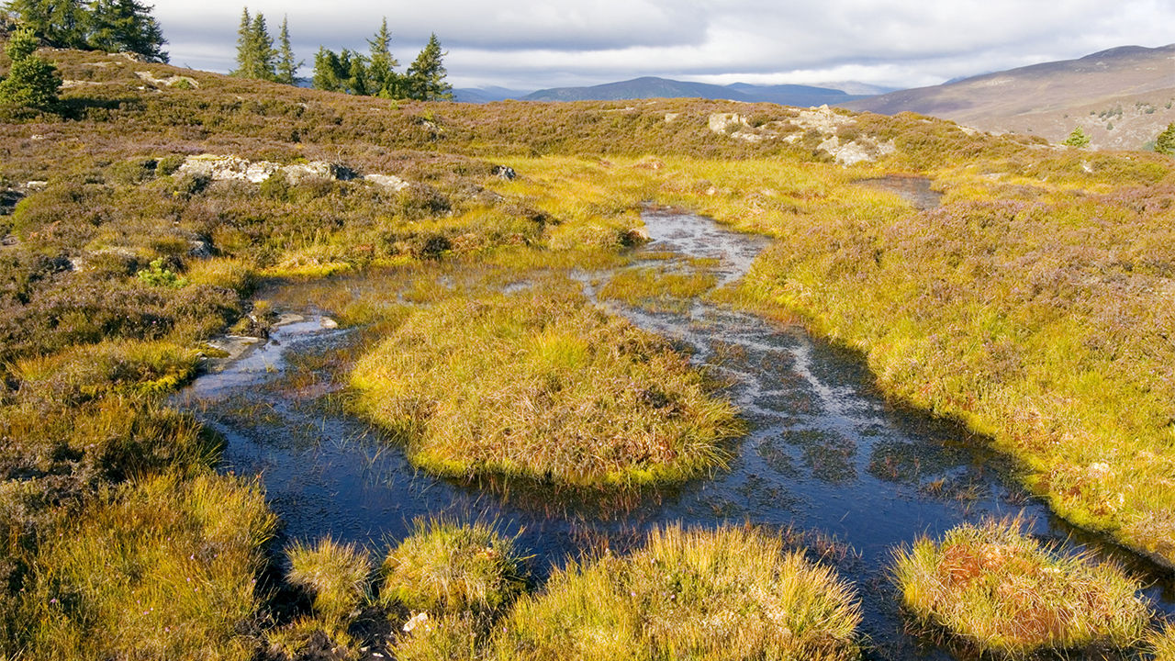
  - Riverine
  - Lacustrine
  - Palustrine
  - Estuarine
  - Marine
- (Tie-breaker 2) What is the dead plant material that bogs accumulate?
- (Tie-breaker 3) What family of naturally occurring organic compounds are they characterized by?
- The process by which a gas changes into a liquid is:
  - Evaporation
  - Precipitation
  - Condensation
  - Sublimation
- Water boils at around which temperature range assuming that atmospheric pressure equals to 1 atm:
  - 0 F and 32 C
  - 32 F and 100 F
  - 32 F and 212 C
  - 100 C and 212 F
- Which of the following is not an example of the slow carbon cycle:
  - Volcanic eruption.
  - Heat and pressure forming pools of stored carbon.
  - A phytoplankton dies and sinks to the bottom of the ocean.
  - Carbon dioxide is transformed into sugar by a plant.
- Is the following cycle of a positive or negative feedback loop? 1 means positive, 2 means negative:
Air warms » More water vapor in the air » More clouds form » More solar radiation reflected to space » Less solar radiation absorbed by surface » Ice and ocean cool, more ice forms » Air warms
- The [H⁺] of water in a stream is 5.3 * 10⁻⁶ mol/L. What is the pOH?
- The only biologically available form of phosphorus compound is:
  - Monosodium phosphate (NaH₂PO₄)
  - Disodium phosphate (Na₂HPO₄)
  - Trisodium phosphate (Na₃PO₄)
  - Orthophosphates (all contain PO₄³⁻)
  - Diammonium phosphate (NH₄)₂HPO₄
- (Tie-breaker 4) Some organism may store excess phosphorus as:
- Which of the following is not a current remedy for phosphate-caused foaming and eutrophication:
  - Using lower phosphate formulas in detergents.
  - Diverting the discharge to a less sensitive location.
  - Precipitating the phosphate with Fe³⁺, Al³⁺, or Ca²⁺.
  - Removal with lime above an operating pH of 8.
- The recommended TDS for drinking water is:
  - <500 mg/L
  - <650 mg/L
  - <900 mg/L
  - <1200 mg/L
- Dark color, accumulated minerals and humus leached from upper horizons
  - O-horizon
  - A-horizon
  - E-horizon
  - C-horizon
  - None of the above
- The act passed by the US Congress in 1974 that establishes a cooperative program among local, state and federal agencies to ensure safe drinking water for consumers.
- A natural underground layer of porous, water-bearing materials usually capable of yielding a large amount or supply of water.
- Pertaining to groundwater, a well or underground basin where the water is under a pressure greater than atmospheric and will rise above the level of its upper confining surface if given an opportunity to do so.
- Select any and all groundwater characteristics:
  - Suspended solids
  - Higher turbidity
  - Low color
  - High hardness
  - Free from microbes
- Which wastewater treatment process produces potable drinking water?
  - Primary Treatment
  - Secondary Treatment
  - Tertiary Treatment
  - None of the above
- What kind of treatment processes (e.g. filtration, softening, aeration) might be needed for:
- Groundwater intended for potable use?
- Water taken from a mountain reservoir and intended for potable use?
- Water taken from the river and intended for potable use?
- What is killing the Chesapeake Bay? Nitrogen, phosphorus, and sediment. Which of the following nonpoint sources produces the highest Chesapeake Bay nitrogen pollution:
  - Septic
  - Wastewater treatment and factories
  - Air pollution
  - Urban and suburban runoff
  - Agricultural runoff
- Ammonium is nitrified to nitrate (NO₂⁻) by Nitrosomanas and then to NO₃⁻ by Nitrobacter. Complete the rest of the following equation:
- NH₄⁺ + 2O₂ »
- If raw sewage contains 10 mg/L phosphate, and a secondary sewage-treatment plant removes 25% of the phosphate, would a secondary treatment plant provide potable water if 0.3 mg/L is the maximum phosphate concentration allowable in drinking water? True = Yes | False = No
- In 1926 Volterra came up with a model to describe the evolution of predator and prey fish populations in the Adriatic Sea. Let N(t) denote the prey population and P(t) the predator population at time t ≥ 0. Select the correct answers that match with what he assumed:
  - When N = 0, the per capita growth rate of the predator ($\frac{1}{P}$$\frac{dP}{dt}$) was constant (and positive).
  - ($\frac{1}{N}$$\frac{dN}{dt}$) = a - abP; where N means prey, a and b are constants, and P means predators.
  - That in the absence of predators (P = 0), the per capita prey growth rate of the prey population N was constant.
  - When P > 0, ($\frac{1}{N}$$\frac{dN}{dt}$) falls linearly as a function of predator population P.
- What must be true regarding the relationship of interspecific competition to intraspecific competition for two species to coexist? In other words, which competition must be greater than the other for coexistence to form?
- What is the water system in the following image called?

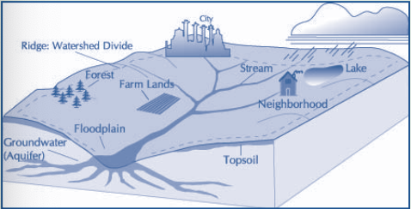

- Sediment is the loose sand, clay, silt and other soil particles that settle at the bottom of a body of water. Sediment can come from soil erosion or from the decomposition of plants and animals. Wind, water and ice help carry these particles to rivers, lakes and streams.
  - Identify two sediment problems.
  - Propose two sediment solutions.
- Which of the following statements describes a sea otter and they way it exerts top-down pressure via predation.
  - A common species that has a strong effect on its community.
  - A rare or uncommon species that has a strong effect on its community.
  - An abundant species that may or may not affect other species.
  - A species that takes up a great deal of space in a community.
- Some aquatic communities are defined by physical features of the abiotic environment rather than by the dominant organisms.
- Which of the following is not a benefit to watershed resource management?
  - Can potentially improve sustainability of resource use while improving economic viability.
  - Can help build community amongst watershed stakeholders by bringing different stakeholders together to address a common problem.
  - Can help improve efficiency of resource management by identifying highest priority issues and fostering collaboration.
  - Helps identify and address both point and nonpoint sources of pollution.
  - Simplifies the task of managing aquatic resources.
- Which of the following describes a K-species
  - Small-sized.
  - Early maturity.
  - Short life expectancy.
  - Energy used to make each individual is high.
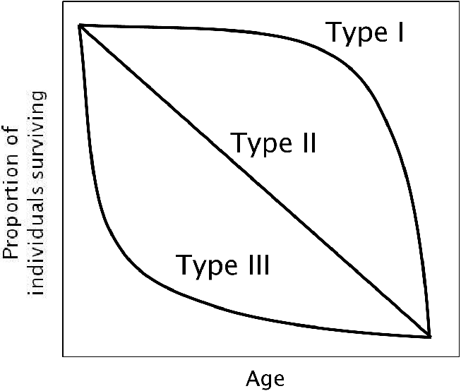
- Based on the following image, which Type do you suppose a banded coral shrimp would be categorized under?

- Iron is an important minor element in aquatic chemistry because it plays a vital oxygen transport mechanism.
- What does TMDL stand for?
  - Tidal & Marine Decay Luminescence
  - Track Mass, Density & Length
  - Total Maximum Daily Load
  - None of the above
- Which of the following about estuaries is correct?
  - San Francisco estuary is a type of tectonic estuary and Chesapeake Bay is a coastal plain estuary.
  - San Francisco estuary is a coastal plain estuary and Chesapeake Bay is a barrier island estuary.
  - San Francisco estuary is a tectonic estuary and Chesapeake Bay is a barrier island estuary.
  - San Francisco estuary is a barrier island estuary and Chesapeake Bay is a coastal plain estuary.
- Which of the following garbage patches is located between HI and CA and is thought to cover an area three the size of France?
  - The Australian Current Patch
  - The Great Pacific Patch
  - The Great Atlantic Patch
  - The Indian Ocean Patch
- The submergence of coastal terrain can signify the presence of:
  - Estuaries
  - Marine terraces
  - Beach drifting
  - Tombolos
  - Atolls
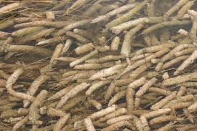
- This group of primary producers are important water quality indicators because it has a fast response to changes. What are these:

- (Tie-breaker 5) Of the 32 largest cities in the word, how many are located on estuaries?
- Non-native species are often introduced to estuaries in the ballast water of ships. When ships are empty, they take in water to help keep them balanced. When cargo is loaded onto the ships, they release the ballast water. In addition to water, aquatic organisms are sucked into the ships' ballast tanks. One of these organisms are zebra mussels. In regards to population dynamics, let’s say that the number of zebra mussels in a river grows at an exponential growth rate of 250% per year. Round your final answer to two significant figures.
  - What is their doubling time? Growth formula: P(t) = P₀ (a)^{t}.
- Describe, in a paragraph, how salt marshes can be a natural disturbance to estuaries. Be sure to relate this to winter ice.
- The California Current is caused by:
  - Thermohaline circulation
  - El Niño
  - Coastal upwelling
  - Gyre circulation

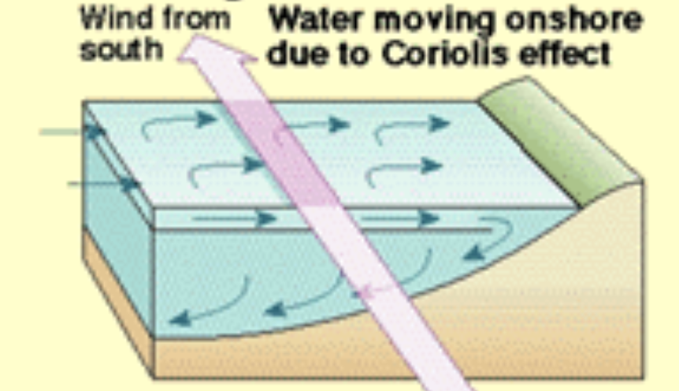
- Use one word to identify the following image.

Part II: Coral Reef Macroflora & Fauna Identification
- Use Figure A and your prior knowledge to answer the following questions:
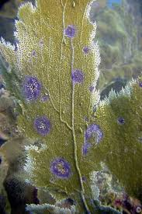

  - Identify Figure A.
  - Identify and describe its relationship with zooxanthellae.
  - Identify and describe the disease’s causation and symptoms.
  - Describe how you could identify the pathogenic microorganisms responsible for causing the diseased coral using Koch’s Postulate.

- Use Figure B and your prior knowledge to answer the following questions:

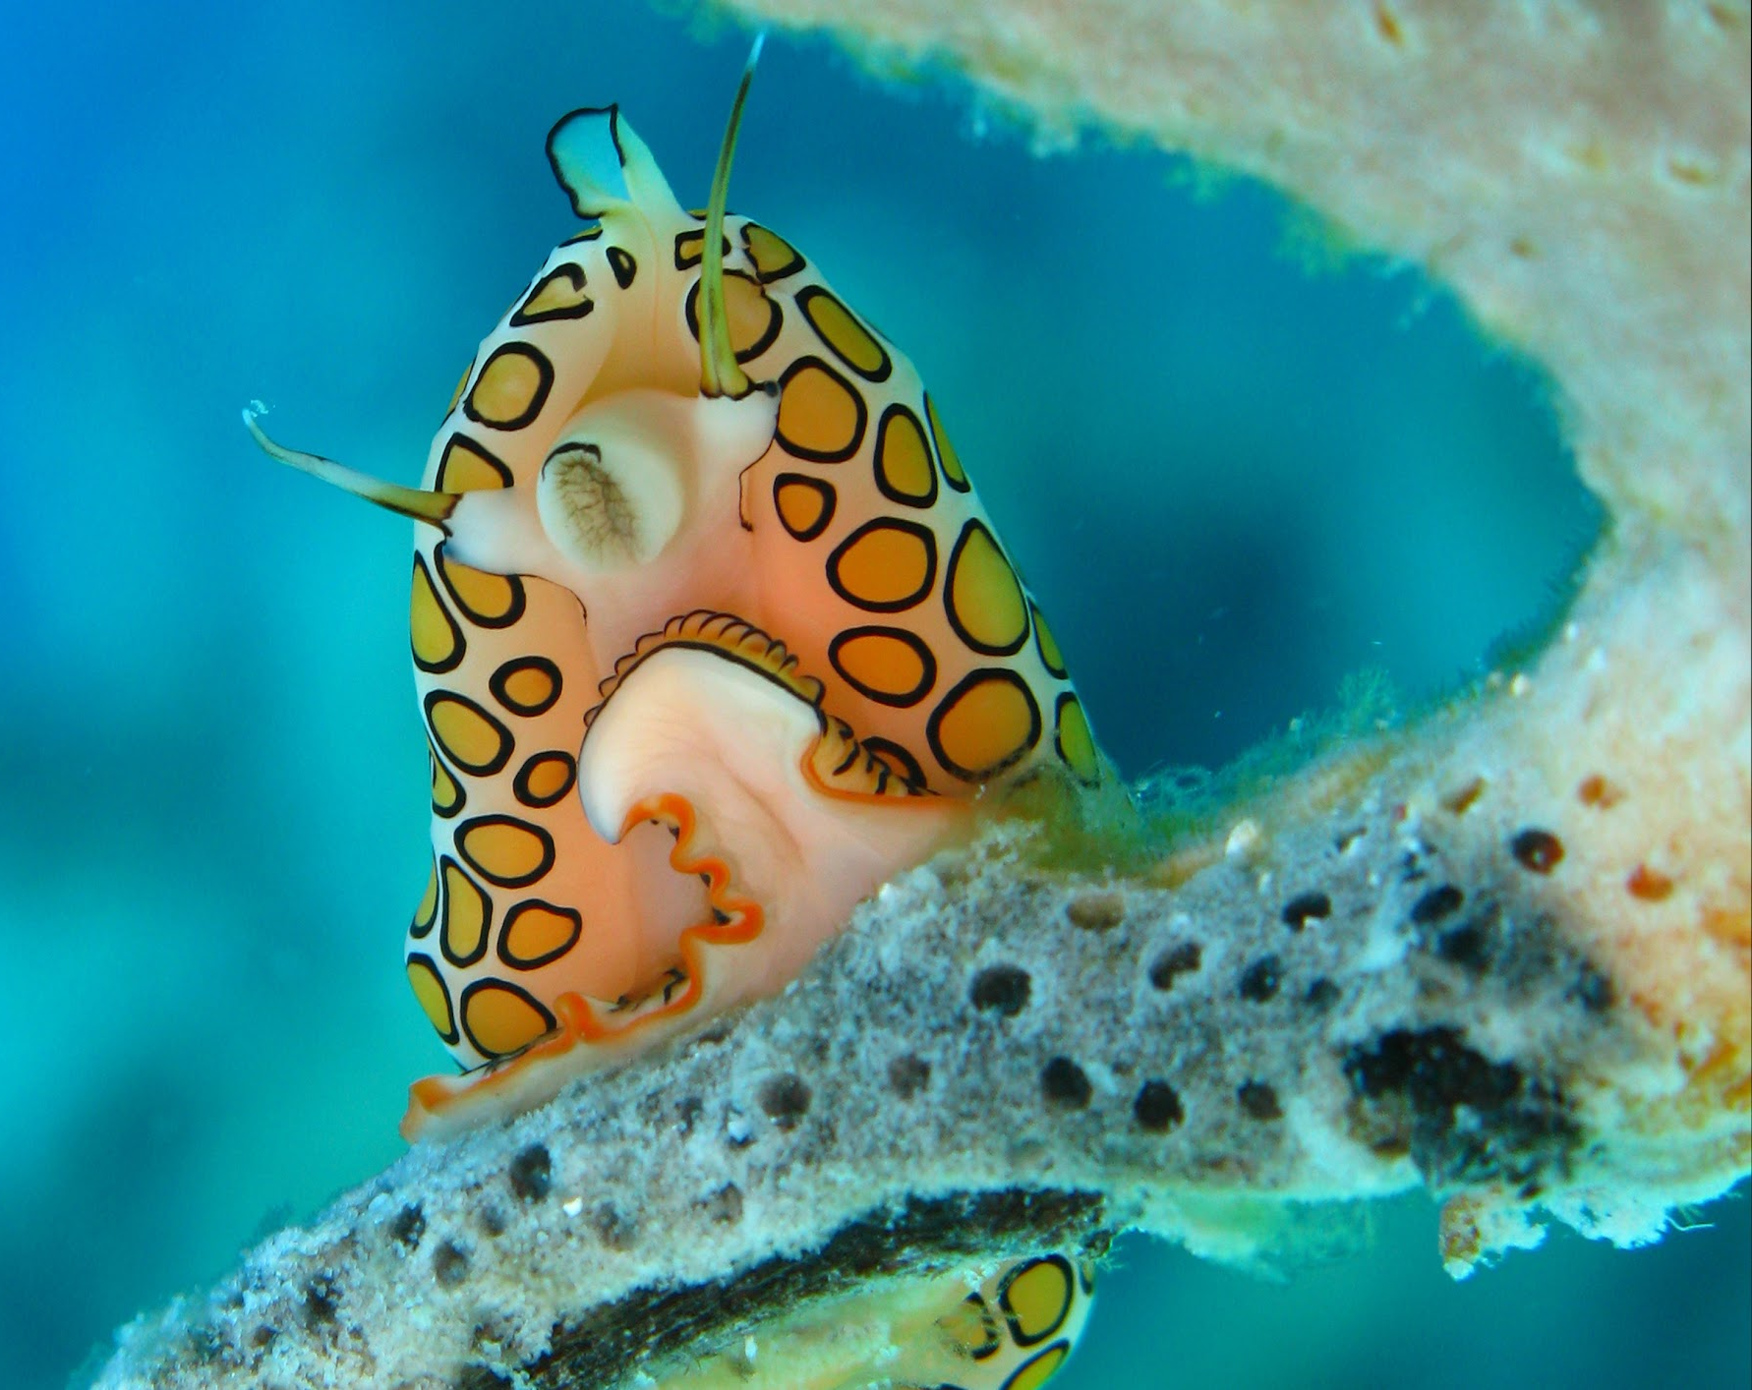
  - Identify Figure B.
  - Identify the region that Figure B is only found in.
  - Identify the phenomena where its bright colors serve as a warning of its poison to potential predators.
  - Describe how Figure B consumes Figure A.
- Use Figure C and your prior knowledge to answer the following questions:
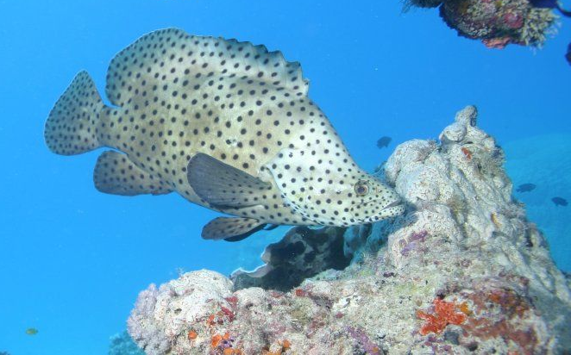

  - Identify Figure C.
  - Describe how we can help these fish from being endangered.
  - Describe what a protogynous hermaphrodite is.
  - True or False, Figure C is not a demersal fish.

- Use Figure D and your prior knowledge to answer the following questions:

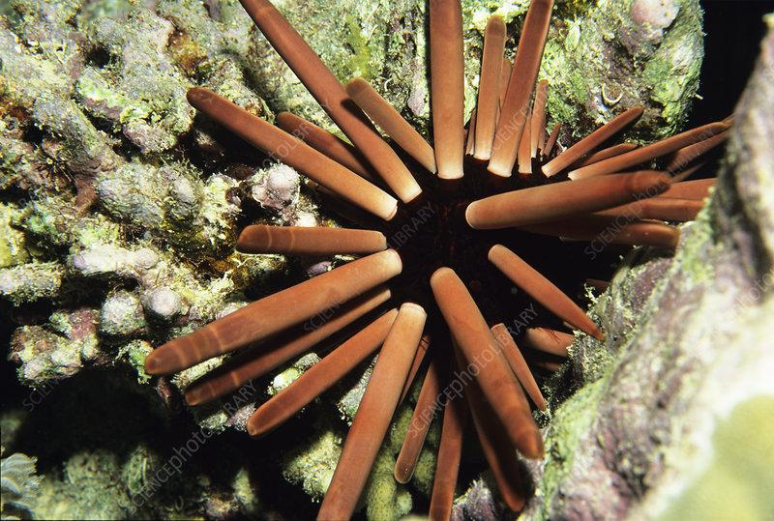
- Identify Figure D.
- What bacterial disease causes its loss of spines and skin lesions? What two pathogens are responsible for the disease?
- What is the center of its entire chewing organ colloquially known as?
- What type of symmetry does it develop during its early juvenile stage before replacing it with a broadly five-fold symmetry appearance?

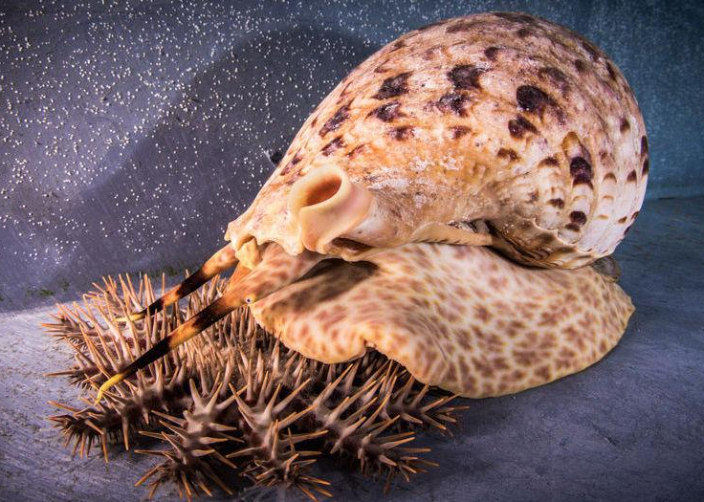
55. Identify the predator and prey in the following image:

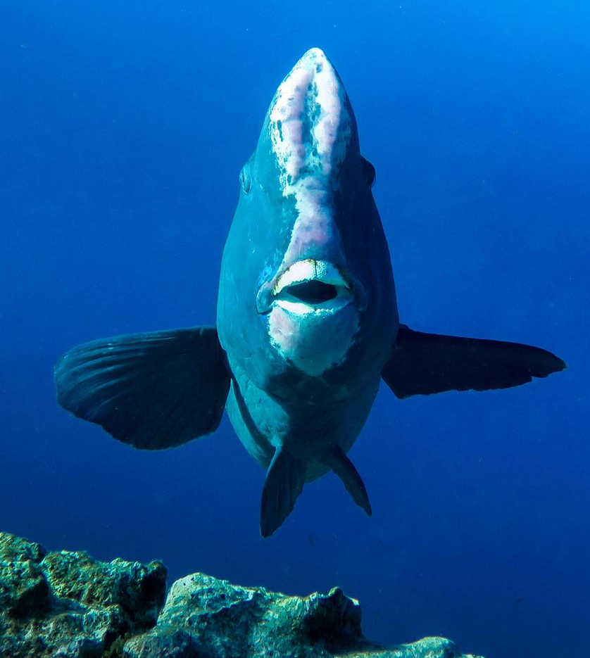
56. Identify the organism in the following image:

57. Identify the organism in the following image:
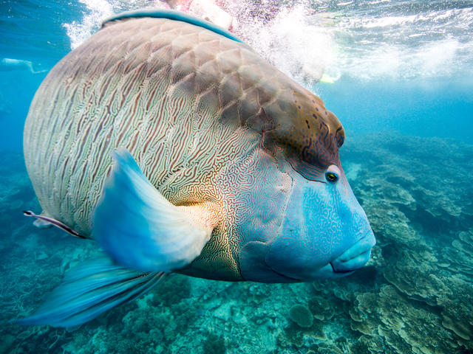

58. Identify the organism in the following image:

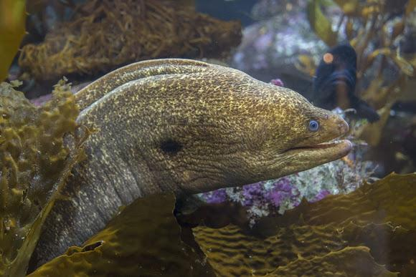

59. Identify the organism in the following image:

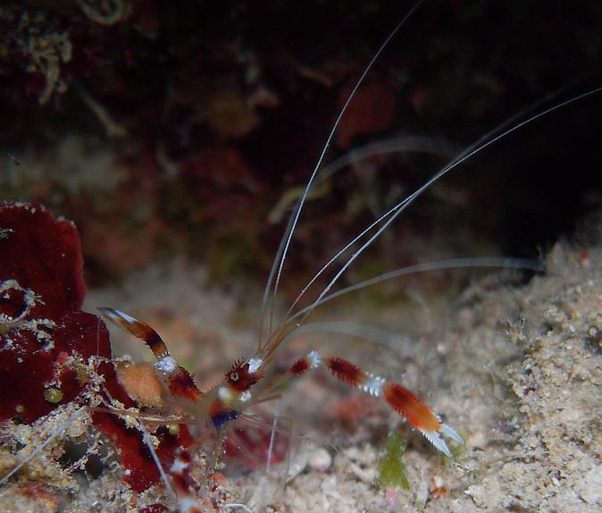

60. Correctly type the scientific name of the organism in Question 58.

Part III: Free-Response Scenarios

Scenario I: Wastewater Technology
61. After the activated sludge treatment stage, industrial wastewater generally still
contains some nitrogen in the forms of organic nitrogen and ammonia. Thus, additional treatment may be required to remove nitrogen from the waste stream. One method for removing nitrogen from wastewater is by air-stripping ammonia. The pH must be raised with caustic compounds to about 10 or higher to convert all ammoniacal nitrogen to the volatile NH₃ form. It should be known that air-stripping ammonia is not a treatment, but a way of transforming contaminants from one phase to another.

Below are is a schematic image of an air-stripping system:

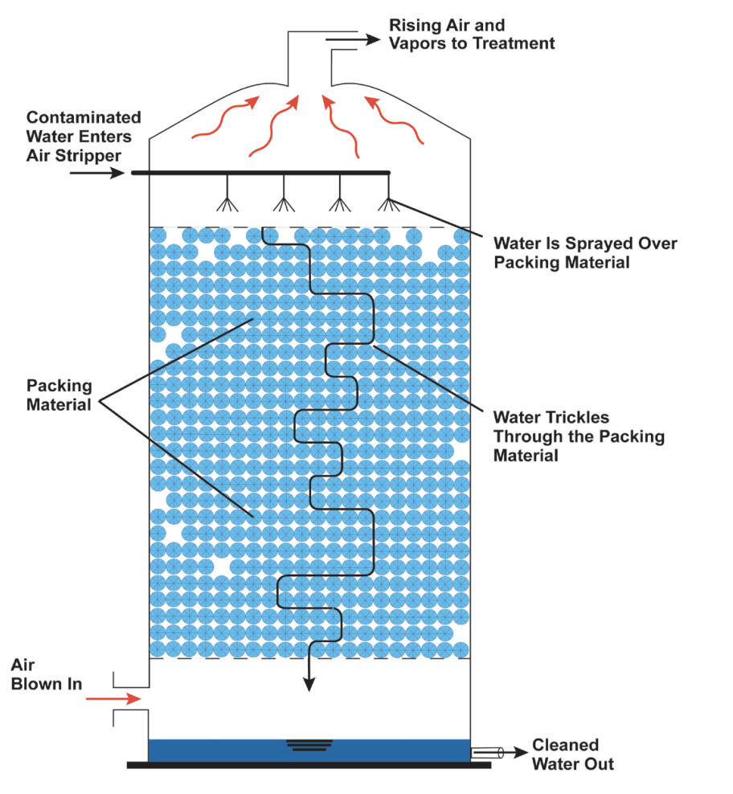

- Describe a generalized schematic of raw sewage water being processed leading up to the activated sludge process (primary to secondary treatment).
- Name one caustic compound that helps with raising the pH of wastewater.
- Based on your response in part c, write a balanced ionic chemical equation that describes how the reactants in the air stripper are being converted into its products.
- Describe how the air stripper works to convert liquid contaminants into ammonia gas (vapor).
- Identify one advantage and one disadvantage to air stripping.

Scenario II: Marine Carbonate Chemistry & Water Hardness
62. Aragonite is a form of calcium carbonate that many marine animals use to build their skeletons and seashells. Aragonite saturation is a ratio that compares the amount of aragonite that is actually present with the total amount of aragonite that the water could hold if it were completely saturated. The more negative the change in aragonite saturation, the larger the decrease in aragonite available in the water, and the harder it is for marine creatures to produce their skeletons and shells. The following image depicts the trend behind the saturation state of aragonite:

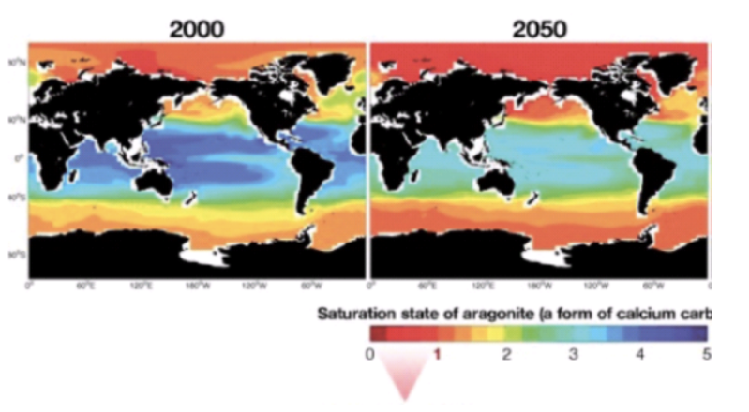
- What graphical color do you expect to not be depicted on the map of the year 2100?
- What is the reason for not depicting that color?
- What is the state of seawater when Ω > 1?

Water hardness is defined as the amount of dissolved minerals, largely calcium and magnesium in a water source. It often represents the largest part of the total dissolved solids found in wastewater treatments. The following image shows a map of water hardness in the United States during the 1975 water year:

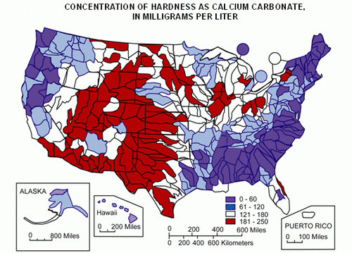

- Identify what region has the largest and lowest concentrations of water hardness.
- Calculate the total hardness as CaCO₃ of a water sample in which Ca²⁺ = 129 mg/L and Mg²⁺ = 18 mg/L. Round your answer to the nearest whole number.
  - CaCO₃ ⇄ Ca²⁺ (aq) + CO₃²⁻ (aq)
  - Equivalent weight = (Molecular or atomic weight)/(Magnitude of ionic charge or oxidation number of either ion)
  - Multiplying factor = (Equivalent weights for ___ ion as CaCO₃)/ (Equivalent weight of ___ ion)
  - Total Hardness = (Ca²⁺ mult. factor)(Ca²⁺, mg/L) + (Mg²⁺ mult. factor)(Mg²⁺, mg/L)
- Describe how high and low levels of water hardness may affect aquatic life.
- Identify two economical advantages to limiting the level of hardness (by softening water).

Scenario III: Watershed Resource Management
63. Trends in watershed management enable stakeholders to isolate raw sewage constituents and microorganisms from river or lake water and further avoid spreading to water borne communicable disease in the biome. Trend analysis is associated with a long term and repeated sampling process in order to assess the water body from improved water supply. Identifying pollution sources and mapping out solutions are one of the first steps in watershed management planning.

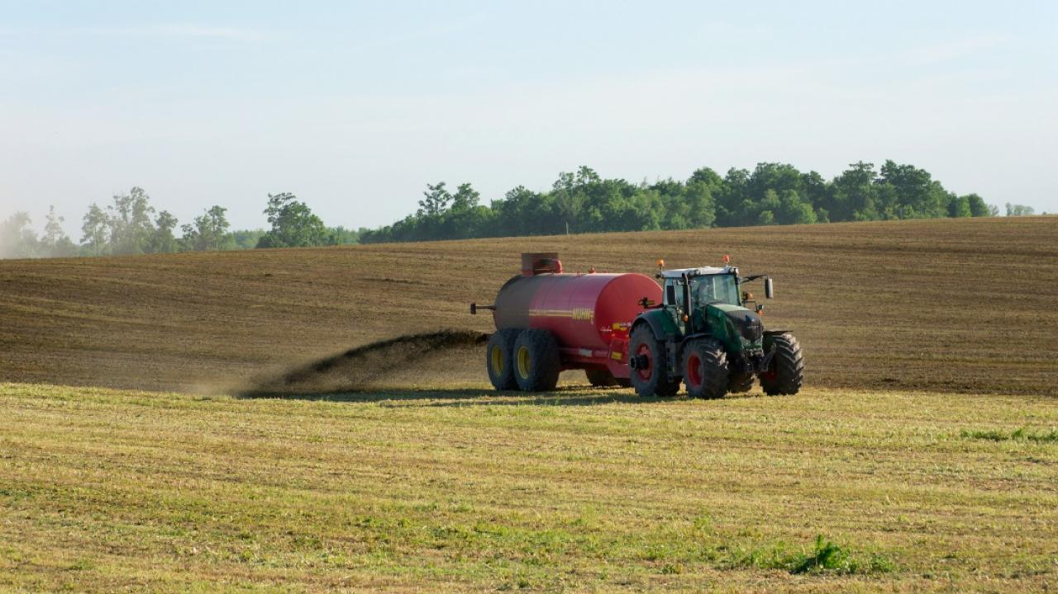

- Identify what overuse of phosphates and their presence in rivers and lake waters can cause.
- Sometimes, phosphate containing fertilizer also possesses cadmium, a heavy metal that can cause itai-itai disease. Describe how an irrigation solution containing high amounts of sodium chloride can affect cadmium concentration in crops.
- Describe how you would reduce the acidity levels in cadmium-containing soil and plants.
- Identify two ways of conducting educational programs that can greatly influence the success of watershed management.

Scenario IV: Life History Table & Population Dynamics
64. You are studying the life of the common rabbit. In a large rabbit colony, you mark 1200 newborn rabbits and observe them for the next 4 years. To clarify, the following useful formulae: d_{x} = (n_{x} - n_{x+1}), q_{x} = (d_{x}/n_{x}), and m_{x} = 1 - (l_{x+1}/ l_{x}) or “One minus (letter l of x+1/letter l of x)”. Below are images of an empty life table and the relevant life table formulas:
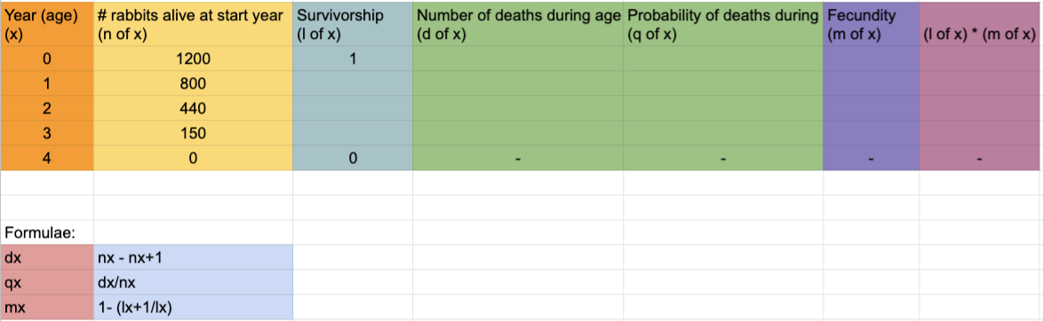

- Define the term fecundity.
- Describe how natural selection relates to fecundity.
- Discuss two methodologies in quantifying egg production patterns in marine invertebrates such as the banded coral shrimp.
- Calculate the remaining values in the life table.
- Calculate the net rate of reproduction = R_{o} = $Σ$ (l_{x}m_{x}).
- Explain what do you expect of this population over the next few years- remain stable, increase in size, or decrease in size?

Conclusion

Congratulations, you have finished the water quality examination.
Please fill out this test feedback survey: tinyurl.com/RateMySciolyTests.
Email: mayurchhitu@gmail.com

